
Computer Science Department
Database Systems 333

Software Requirements for [Aya Shop]
[510]
[Aya Dahbour]
[Osaid Ghanem]

Summary
This project is about creating an online clothing store webpage for an existing clothing store that will allow customers to view the store's products online, including pictures and prices, and make purchases through the website. The goal is to provide a convenient shopping experience for customers and enhance the store's e-commerce activity.

Introduction
Our client is a new clothing store that has recently entered the market and is looking to expand their customer base beyond their online messaging platform. Although the store accepts orders through messages, they recognize the potential of online sales and have enlisted our help to create a simple webpage that allows customers to view and purchase their products with ease. Our solution will provide a convenient online shopping experience for customers and streamline inventory management and sales tracking processes for the client, helping them establish a strong online presence, increase e-commerce activity, and achieve greater profitability.

Data Requirements

➢ The Entities
- Customer: Represents a customer who can view and purchase clothing products, with attributes such as customer id (as primary key), first Name, last Name, Birth Date, email, and password.
- Product: Refers to a clothing item available for sale on the online store. This entity has attributes such as product ID (as primary key), name, Product description, and price.
- Order: Represents an order made by a customer for one or more clothing products, with attributes such as order ID (as primary key), order date, and total price.,
- Payment: Refers to a payment made by a customer for an order. This entity has attributes such as payment ID (as primary key), payment method, and amount.
- Address: Represents the delivery address entered by the customer while placing an order. This entity has attributes such as address ID (as primary key), street, phone, village, and city.
- Cart: Represents the products that the customer has ordered. This entity has attributes such as cart ID (as primary key), number of products, and total price.
- Admin: Represents the manager of the clothing store who can access the web application. This entity has attributes such as admin ID (as primary key), username, and password.
- Category: Represents the category of the product. This entity has attributes such as category ID (as primary key), category name, picture, and description.
- The Relationships
  - One customer can place zero or many orders.
  - One order is made by one customer.
  - One order can contain one or many products.
  - One product can be included in zero or many orders.
  - One payment can be made for one order.
  - One address can be associated with one or many orders.
  - One cart can be associated with one or many orders.
  - One order can be associated with one or many carts.
  - One cart can have one or more products.
  - One admin can access all tables (entities).
  - One category can be associated with one or many products.

ER Diagram

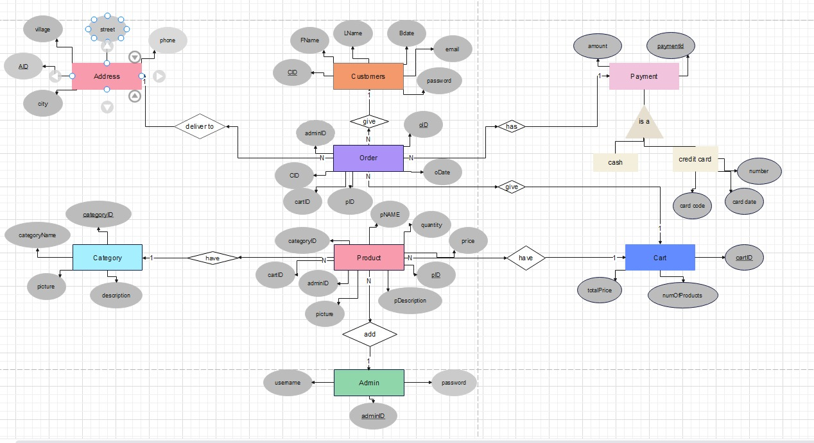

Technology
As we mentioned in phase0, we will be using modern computers running on Windows OS. Our database system of choice is SQL, while our programming language is Java, and we will be using JavaFX to develop the user interface. By utilizing these technologies, we aim to create a robust and user-friendly online store that will help our client reach a wider audience and efficiently manage his business.

